# JavaScript OOP Exam – Travel Agency

A travel agency offers several **travels** – **excursions**, **vacations** and **cruises**. Travels hold **name**, **start date**, **end date** and **price**. **Vacations** are travels with a **location** and **accommodation**. Excursions are travels with a **set of destinations** and a means of **transport**. Cruises are excursions with a **starting dock**.

### Engine

You are given an engine which consists of two main parts: **TravellingManager** which holds the core logic of the application and **Models** which holds the classes. The **TravellingManager** contains a module for **processing commands** from the console. It currently supports the following commands:

* **insert** – adds a travel/destination to the engine
* **delete** – deletes a travel/destination from the engine. **Note**: Deleted destinations are removed from all travels they are in.
* **add-destination** – adds a destination to a specified Excursion / Cruise
* **remove-destination** – removes a destination from a specified Excursion / Cruise
* **list** – prints all travels in their order they were added to the engine. Travel **destinations** are also printed in the order they were added to the travel. (Refer to the output to see printing format.)

You are **not allowed to change the Engine structure** so you may only write in the **TravellingManager** and **Models** modules.

### Implement the Missing Classes

**Implement all missing classes** to model the travel agency using the **best practices** of JavaScript object-oriented programming (OOP). **Avoid duplicated code** through inheritance. Encapsulate correctly all fields with **getters** and **setters** with **data validation**. Create the following function constructors (i.e. "classes"):

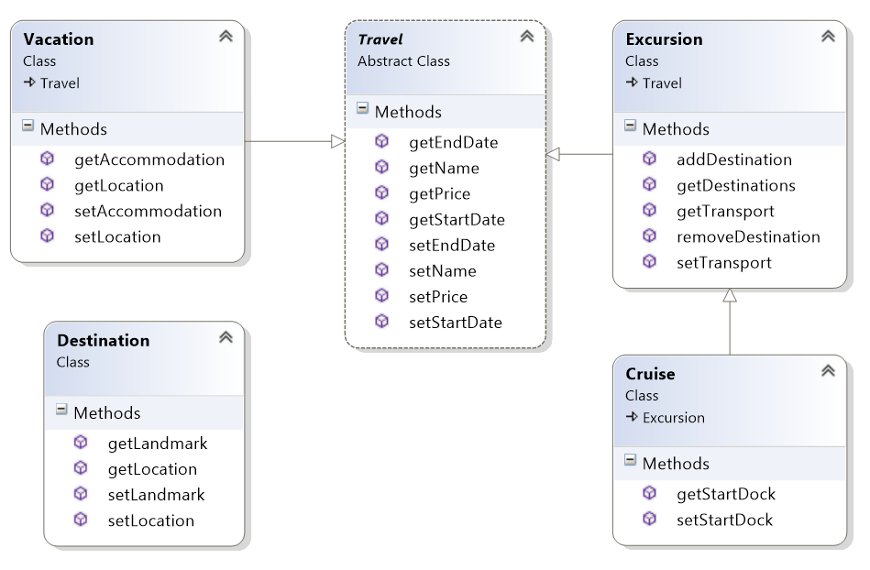

* **Destination** – already fully implemented, holds **location** and **landmark**
* **Travel** – holds **name**, **startDate**, **endDate** and **price**
* **Excursion** – holds a **set of destinations** and **transport**, holds **addDestination()** and **removeDestination()** methods – throws an error if it contains no such destination
* **Vacation** – holds **location** and **accommodation**
* **Cruise** – holds **start** **dock**, **transport** is always "cruise liner"

### Implement Additional Commands

Implement the following commands:

* **filter** – filters all travels by **type** (unless specified "all") and in a specified **price range** (inclusive). Returns the travels **sorted** by their **start date** in ascending order, then by **name** (always unique) as secondary criteria.

### Validate the Data

The "class" fields should follow the given validity rules:

* Travel **name** should be a non-empty string
* Travel **start date** should be a valid Date object
* Travel **end date** should be a valid Date object
* Travel **price** should always be a non-negative **number**
* Vacation **location** should be a non-empty string
* Vacation **accommodation** is **optional** andshould be a non-empty string when it exists
* Excursion **transport** should be a non-empty string
* Cruise **starting** **dock** is **optional** and should be a non-empty string when it exists

All thrown errors are handled by the engine and the message "**Invalid command.**" is displayed.

#### Sample Test #1

|  |
| --- |
| **Input** |
| **insert**(type=vacation;name=Karibska prikazka;price=3400.00;start-date=22-Jun-2015;end-date=4-Jul-2015;location=Caribbean Sea;accommodation=hut)  **insert**(type=vacation;name=Havaiska zima;price=2600.00;start-date=22-Dec-2014;end-date=4-Jan-2015;location=Hawaii Islands)  **insert**(type=excursion;name=Do Chikago i nazad;price=1250.50;start-date=17-Dec-2014;end-date=28-Dec-2014;transport=bus and cruiser)  **insert**(type=excursion;name=Tibet;price=1250.50;start-date=17-Dec-2014;end-date=28-Dec-2014;transport=bus)  **insert**(type=cruise;name=Transatlantic cruise;end-date=16-Jan-2015;start-date=2-Jan-2015;price=1778.00;start-dock=Lisbon)  **insert**(type=cruise;name=Pacific cruise;end-date=29-Mar-2015;start-date=3-Mar-2015;price=1778.00)  **insert**(type=destination;location=Chicago;landmark=Niagara Falls)  **insert**(type=destination;location=New York;landmark=Statue of Liberty)  **add-destination**(name=Do Chikago i nazad;location=Chicago;landmark=Niagara Falls)  **add-destination**(name=Do Chikago i nazad;location=New York;landmark=Statue of Liberty)  **list** |
| **Output** |
| Vacation created.  Vacation created.  Excursion created.  Excursion created.  Cruise created.  Cruise created.  Destination created.  Destination created.  Added destination to Do Chikago i nazad.  Added destination to Do Chikago i nazad.  * Vacation: name=Karibska prikazka,start-date=22-Jun-2015,end-date=4-Jul-2015,price=3400.00,location=Caribbean Sea,accommodation=hut  * Vacation: name=Havaiska zima,start-date=22-Dec-2014,end-date=4-Jan-2015,price=2600.00,location=Hawaii Islands  * Excursion: name=Do Chikago i nazad,start-date=17-Dec-2014,end-date=28-Dec-2014,price=1250.50,transport=bus and cruiser  ** Destinations: Destination: location=Chicago,landmark=Niagara Falls;Destination: location=New York,landmark=Statue of Liberty  * Excursion: name=Tibet,start-date=17-Dec-2014,end-date=28-Dec-2014,price=1250.50,transport=bus  ** Destinations: -  * Cruise: name=Transatlantic cruise,start-date=2-Jan-2015,end-date=16-Jan-2015,price=1778.00,transport=cruise liner  ** Destinations: -  * Cruise: name=Pacific cruise,start-date=3-Mar-2015,end-date=29-Mar-2015,price=1778.00,transport=cruise liner  ** Destinations: - |

#### Sample Test #2

|  |
| --- |
| **Input** |
| **insert**(type=vacation;name=Vakanciq;price=3400.00;start-date=22-Jun-2015;end-date=4-Jul-2015;location=Caribbean Sea;accommodation=hut)  **insert**(type=excursion;name=US travel;price=800.80;start-date=12-Jan-2015;end-date=29-Jan-2015;transport=plane)  **insert**(type=excursion;name=Dunavska prikazka;price=1350.22;start-date=6-Nov-2014;end-date=24-Dec-2014;transport=motorboat)  **insert**(type=cruise;name=Transatlantic cruise;end-date=16-Jan-2015;start-date=2-Jan-2015;price=1778.00;start-dock=Lisbon)  **insert**(type=destination;location=Budapest;landmark=Chain Bridge)  **insert**(type=destination;location=New York;landmark=Statue of Liberty)  **insert**(type=destination;location=California;landmark=Yosemite National Park)  **add-destination**(name=US travel;location=New York;landmark=Statue of Liberty)  **add-destination**(name=US travel;location=California;landmark=Yosemite National Park)  **add-destination**(name=Dunavska prikazka;location=Budapest;landmark=Chain Bridge)  **add-destination**(name=Transatlantic cruise;location=New York;landmark=Statue of Liberty)  **filter**(type=excursion;price-min=200;price-max=1000.00)  **remove-destination**(name=US travel;location=California;landmark=Yosemite National Park)  **delete**(type=destination;location=New York;landmark=Statue of Liberty)  **filter**(type=all;price-min=200;price-max=5000.00) |

|  |
| --- |
| **Output** |
| Vacation created.  Excursion created.  Excursion created.  Cruise created.  Destination created.  Destination created.  Destination created.  Added destination to US travel.  Added destination to US travel.  Added destination to Dunavska prikazka.  Added destination to Transatlantic cruise.  * Excursion: name=US travel,start-date=12-Jan-2015,end-date=29-Jan-2015,price=800.80,transport=plane  ** Destinations: Destination: location=New York,landmark=Statue of Liberty;Destination: location=California,landmark=Yosemite National Park  Removed destination from US travel.  Destination deleted.  * Excursion: name=Dunavska prikazka,start-date=6-Nov-2014,end-date=24-Dec-2014,price=1350.22,transport=motorboat  ** Destinations: Destination: location=Budapest,landmark=Chain Bridge  * Cruise: name=Transatlantic cruise,start-date=2-Jan-2015,end-date=16-Jan-2015,price=1778.00,transport=cruise liner  ** Destinations: -  * Excursion: name=US travel,start-date=12-Jan-2015,end-date=29-Jan-2015,price=800.80,transport=plane  ** Destinations: -  * Vacation: name=Vakanciq,start-date=22-Jun-2015,end-date=4-Jul-2015,price=3400.00,location=Caribbean Sea,accommodation=hut |